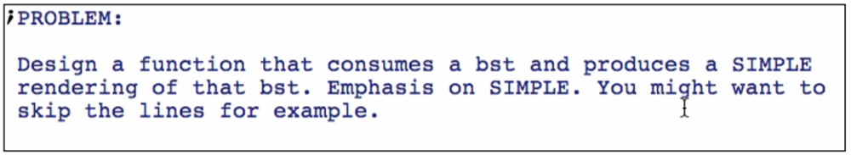

Sketch

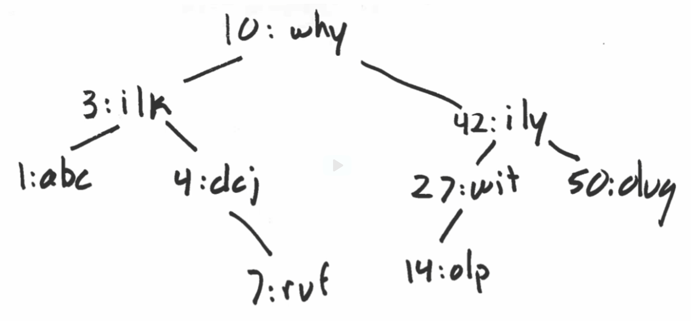

Making it simple: (skip the lines)

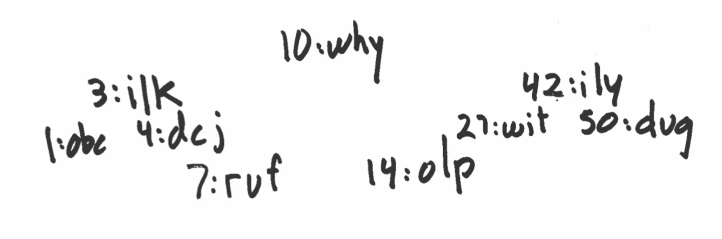

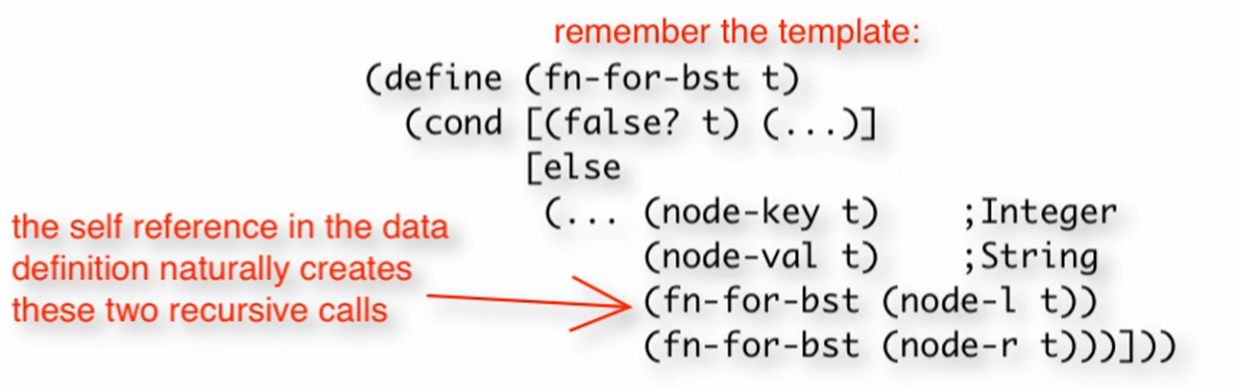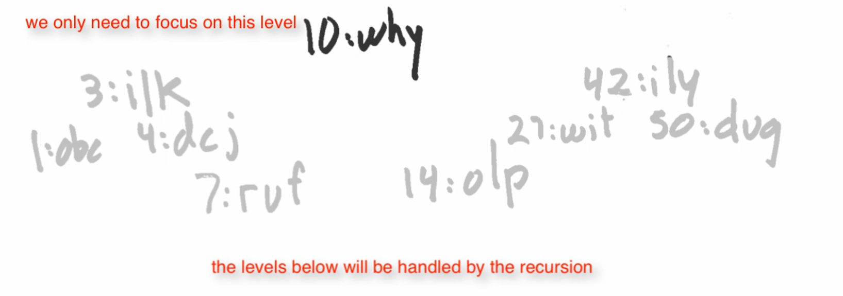

Rendering of subtrees are handled by the recursion!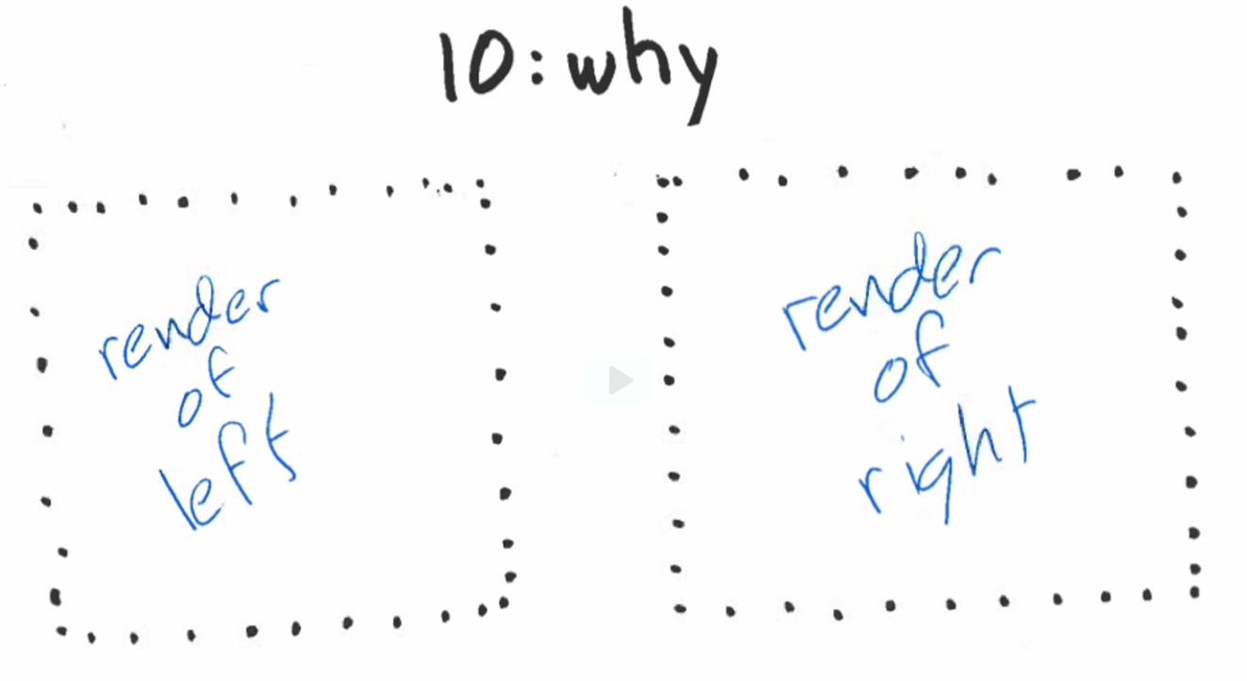

Making our sketch more detailed

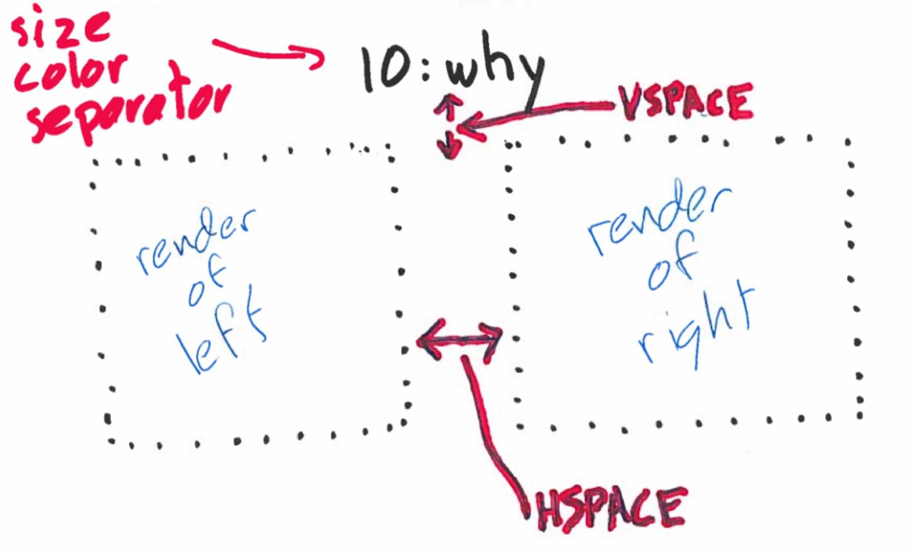

***Constants*** *(before data definition)*

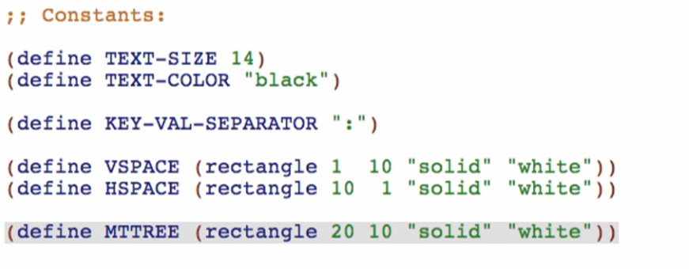

***Function – render-bst***

**Signature, purpose and stub**

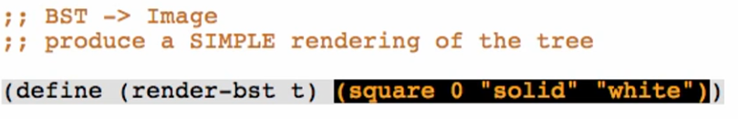

Check if well-formed

**Examples**

Base case:



Other cases:

*Empty both sides:*

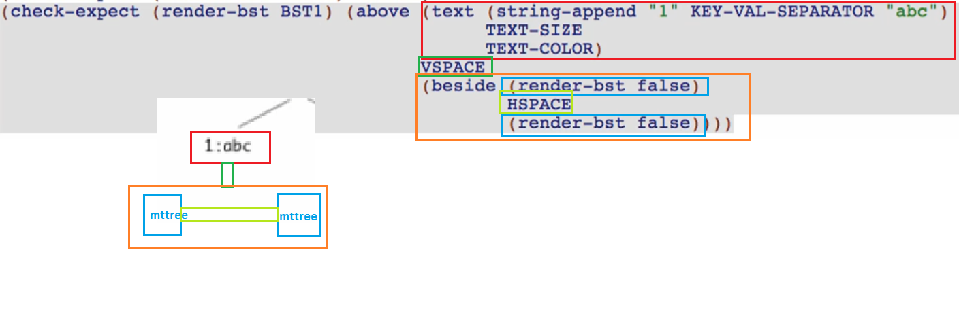

Check if well-formed and check if you got what you want in check-expects: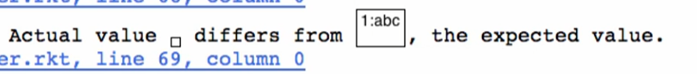

*has one subtree*

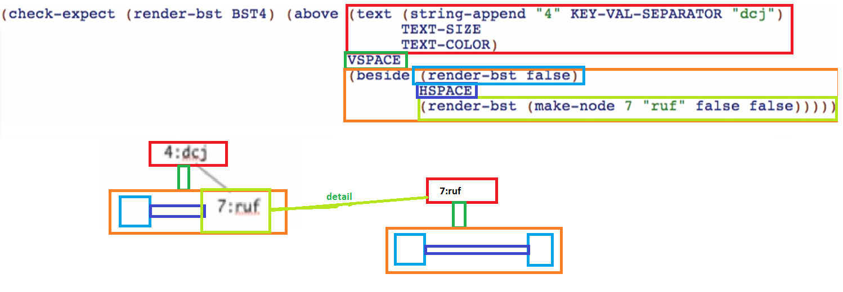

We already tested a tree without any subtrees, so we can use that render-bst on the right side!

*Has both subtree*

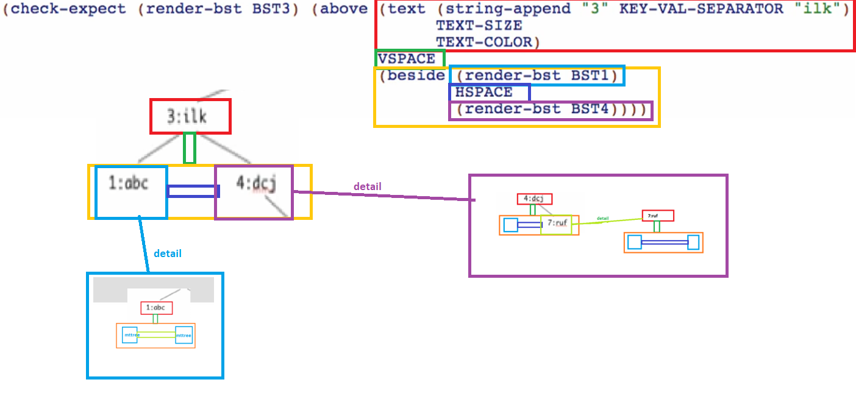

**Template**

Rename function & natural recursions

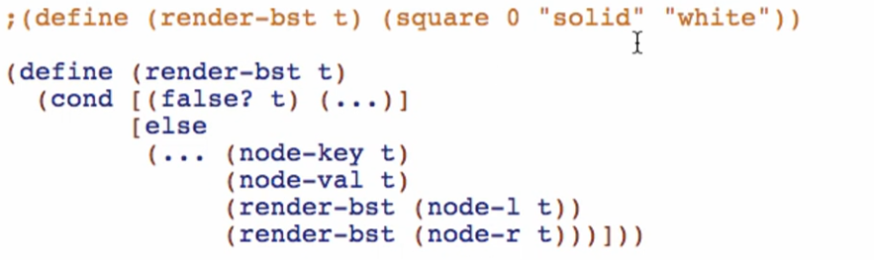

**Code body**

Base case:

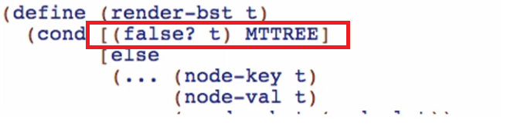

Other cases (all other since they are just the same if recursion is applied!)

